SHREYA PANCHAL
LINUX Assessment:
Server Security and Automation
Theme: Startup Web Server Deployment
Section A: Scenario-Based Concept Application
1. Explain the operational factors that justify selecting a specific Linux distribution for a startup’s internal tool hosting environment.
Answer: A startup should select a Linux distribution based on:
- Stability – Long-term stable releases reduce unexpected failures.
- Security – Regular security updates and SELinux/AppArmor support.
- Community Support – Large documentation and community forums.
- Package Management
  - Ubuntu → APT
  - CentOS/RHEL → DNF/YUM
- Performance – Low hardware requirements.
- Cost – Ubuntu is free; RHEL provides enterprise support.
- Compatibility – Supports Apache, Nginx, Docker, Kubernetes, MySQL, etc.
- Long-Term Support (LTS) – Receives updates for several years.
Example: Ubuntu Server LTS is ideal for startups because it is free, stable, secure, and easy to maintain.
2. Explain the implementation of SSH Key-based Authentication to satisfy a security requirement where password logins must be disabled for developer access.
Answer: SSH Key Authentication uses a public/private key pair instead of passwords.
Steps:
1.Generate Key= #ssh-keygen -t rsa -b 4096
2. Copy Public Key= #ssh-copy-id user@server-ip
3. Disable Password Authentication= #nano /etc/ssh/sshd_config ,
entry: 1.PasswordAuthentication no , 2. .PubkeyAuthentication yes , 3. PermitRootLogin no
4.Restart SSH= #systemctl restart ssh
Advantages: Prevents brute-force attacks , More secure than passwords ,Faster login , Supports automation
3. Explain the configuration of Linux Permissions and Ownership for the /var/www directory to support a multi-user environment.
Answer: Suppose multiple developers manage the website.
Create Group = #groupadd webadmins
Add Users = #usermod -aG webadmins dev-ops
Change Group Ownership = #chown -R root:webadmins /var/www
Set Permissions = #chmod -R 775 /var/www
Set SGID = #chmod g+s /var/www
Benefits: Only webadmins can modify files., Others have read-only access., New files inherit the webadmins group.
4. Explain how Logical Volume Management (LVM) facilitates dynamic storage expansion to prevent service downtime when disk space is depleted.
Answer: LVM allows storage to be expanded without reinstalling Linux or causing downtime.
Components: Physical Disk ↓Physical Volume (PV)↓Volume Group (VG)↓Logical Volume (LV)↓Filesystem
Step:
Create PV= #pvcreate /dev/sdb
Create VG= #vgcreate web_vg /dev/sdb
Create LV= #lvcreate -L 20G -n web_lv web_vg
Extend LV= #lvextend -L +10G /dev/web_vg/web_lv
Resize Filesystem= #resize2fs /dev/web_vg/web_lv
Advantages: Online storage expansion , Snapshot support , Better storage management , No downtime
5. Explain the troubleshooting process for diagnosing and resolving service blocks caused by SELinux security policies when a website becomes inaccessible.
Answer: Website returns 403, 500, or cannot access files.
Check SELinux Status= #getenforce
View Logs= #journalctl | grep AVC
Check Context= #ls -Z /var/www/html
Restore Context= #restorecon -Rv /var/www/html
Temporary Test= #setenforce 0
Permanent Configuration= #chcon -R -t httpd_sys_content_t /var/www/html
Result: Apache can access files securely while SELinux remains enabled.
6. Explain the safe configuration of Cron Jobs to ensure critical daily backup tasks execute automatically at a scheduled time.
Answer:
Create Backup Script= # nano /usr/local/bin/backup.sh
entry= #!/bin/bash
tar -czf /backup/web-$(date +%F).tar.gz /var/www
Make Executable= #chmod +x /usr/local/bin/backup.sh
Edit Cron= #crontab -e
entry= Daily at 2 AM= 0 2 * * * /usr/local/bin/backup.sh
Verify= #crontab -l
Benefits: Automatic backups , Scheduled execution , No manual intervention

Section B: Practical Application
1. system Identity: Set the system hostname to startup-web-01 and verify the change via CLI.
Answer:
Change Hostname: #hostnamectl set-hostname startup-web-01
Verify: #hostname or #hostnamectl
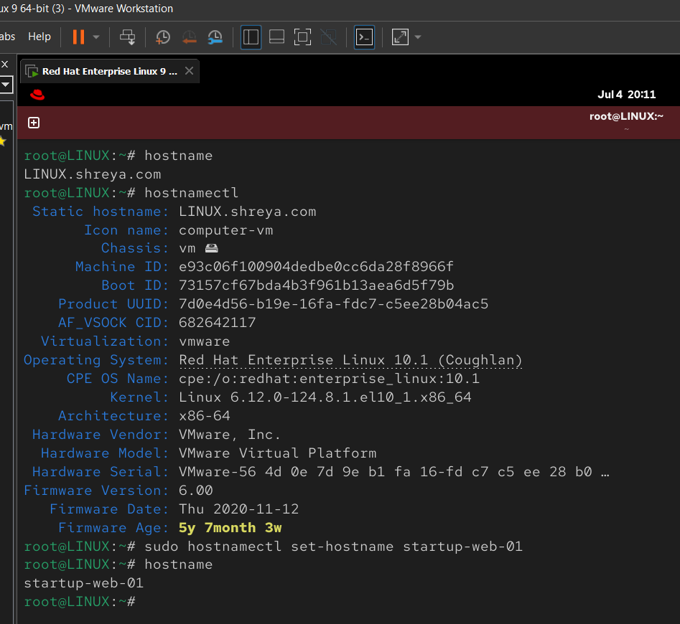

2. Network Setup: Configure a static IP address on the primary interface and restart the networking service.
Answer:
1.Configure Static IP:
Check interface name= #ip addr , output interface: ens160
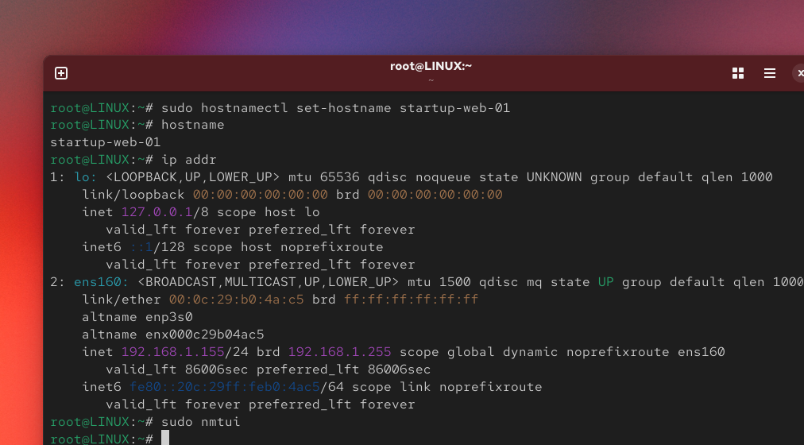Edit Network Manager connection= #nmtui
Steps:
1. Edit a connection
2. Select interface (e.g., ens160)
3. IPv4 Configuration → Manual
4. Entry:
  - IP Address: 192.168.1.100/24
  - Gateway: 192.168.1.1
  - DNS: 8.8.8.8
5. Save and Exit
6. Restart Network: #systemctl restart NetworkManager
7. Verify= #ip addr
8. Check connectivity: # ping -c 4 8.8.8.8
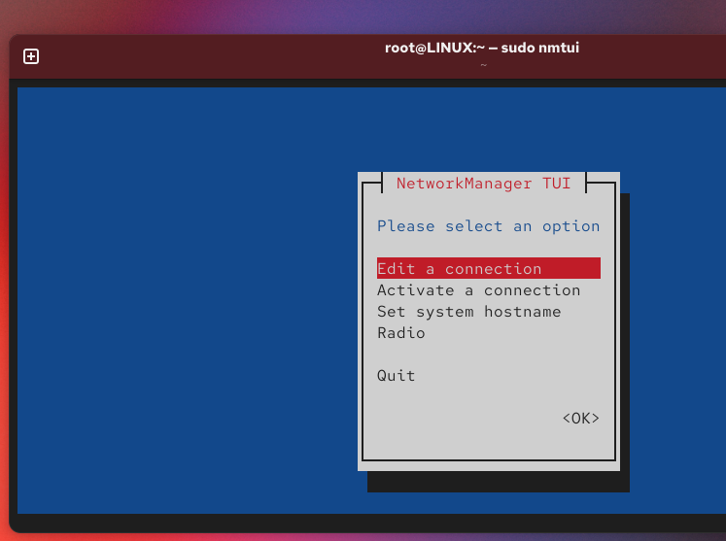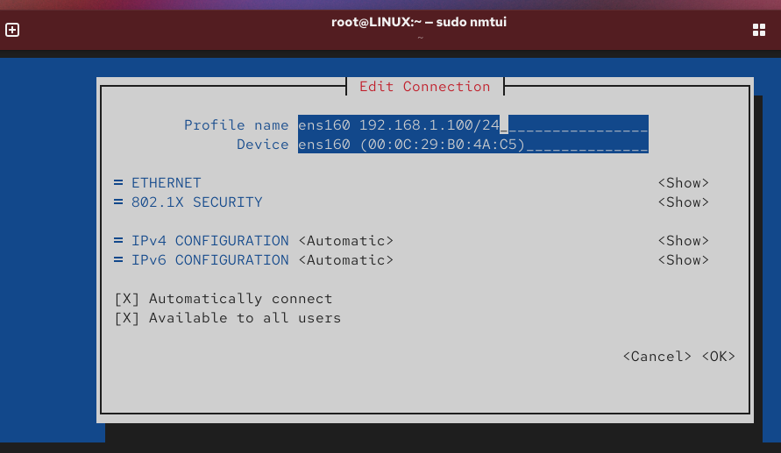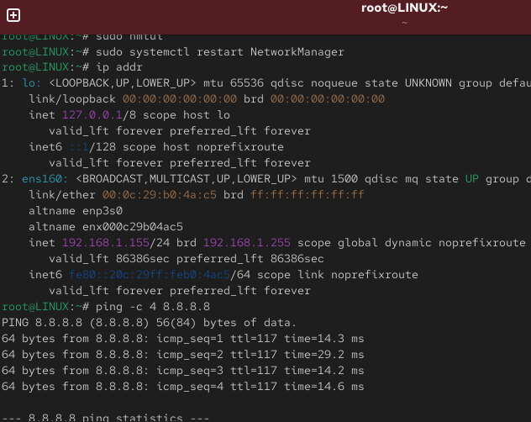
3. Secure Access: Enable the SSH service and ensure it starts automatically on system boot.
Answer:
Install SSH Server= #dnf install openssh-server -y
Start SSH= #systemctl start sshd
Enable on Boot= #systemctl enable sshd
Verify= #systemctl status sshd
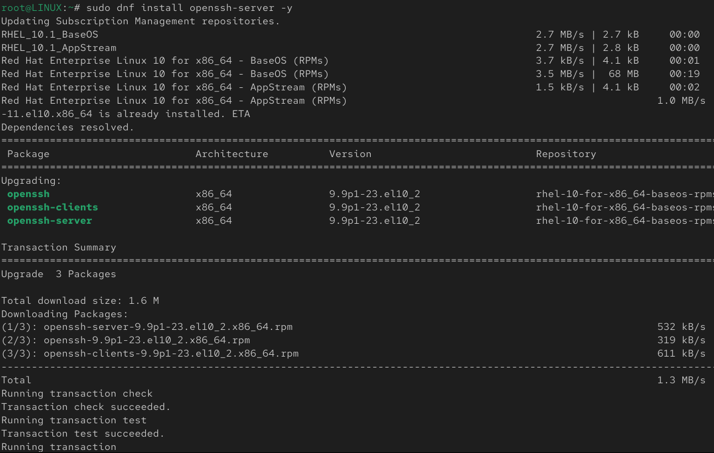
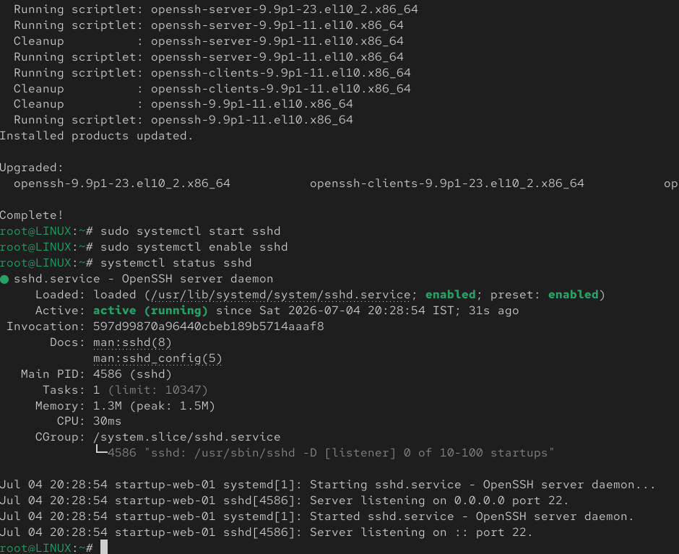

4. Access Control: Create a group named webadmins and a user dev-ops with restricted sudo privileges.
Answer:
Create Group= #groupadd webadmins
Create User= #useradd dev-ops
Set Password= #passwd dev-ops
Add User to Group= #usermod -aG webadmins dev-ops
Entry Sudo Permission= #visudo , entry: dev-ops ALL=(ALL) /bin/systemctl,/usr/bin/systemctl
Verify= #id dev-ops
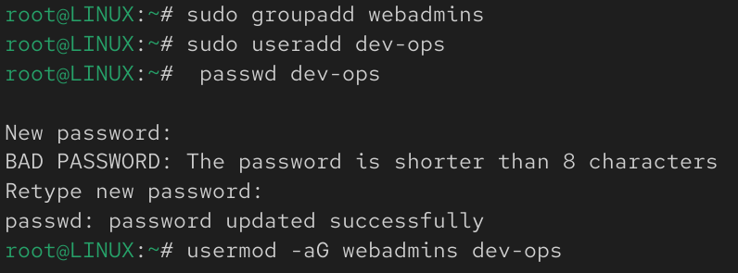
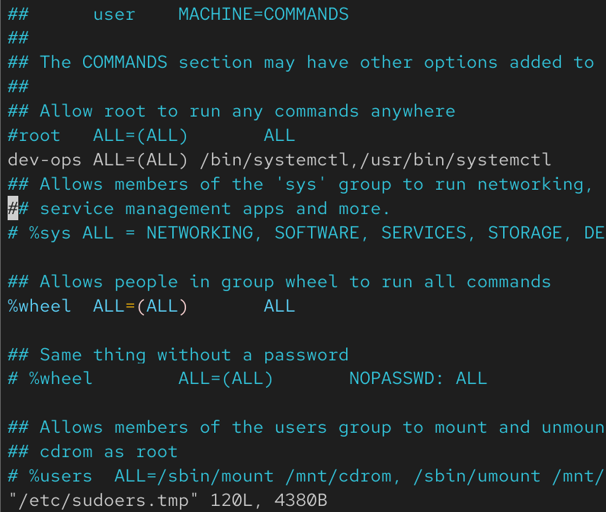
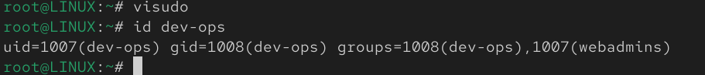

5. Web Hosting: Install the Apache service and deploy a custom index.html file to /var/www/html.
Answer:
Install Apache= #yum dnf install httpd
website file path= cd /var/www/html
create file= #sudo nano Shreya.html , enter the website code.
show website= #ls /var/www/html
show website code= cat /var/www/html/Shreya.html
Start Apache= #systemctl start httpd
Enable on Boot= #systemctl enable httpd
restart Apache= #systemctl restart httpd
Delete website file= #sudo rm -f Shreya.html
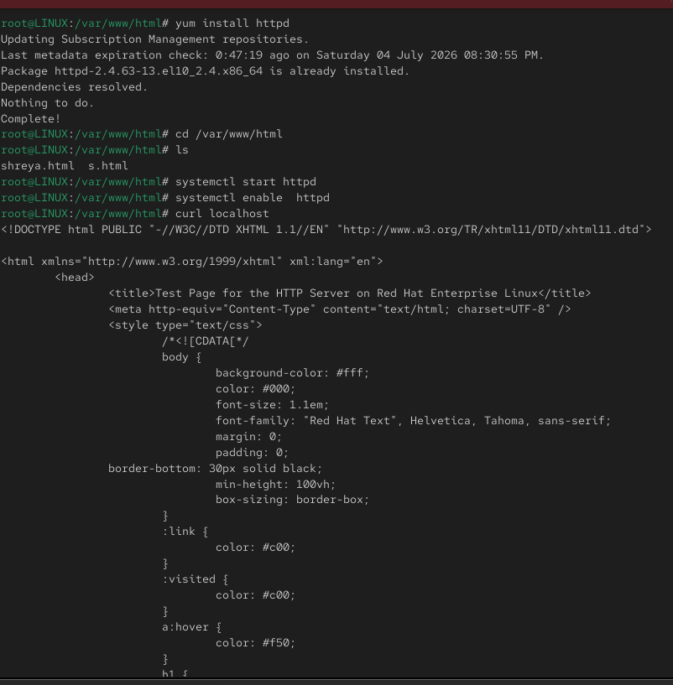
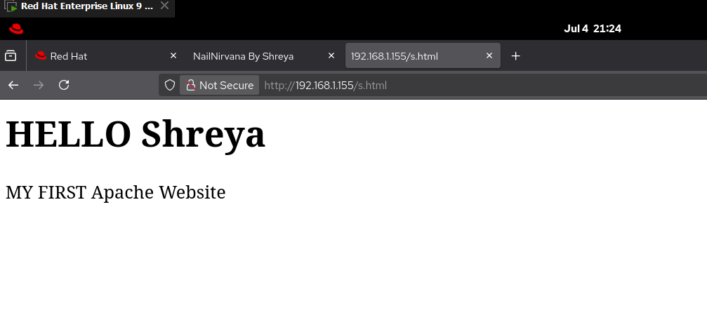
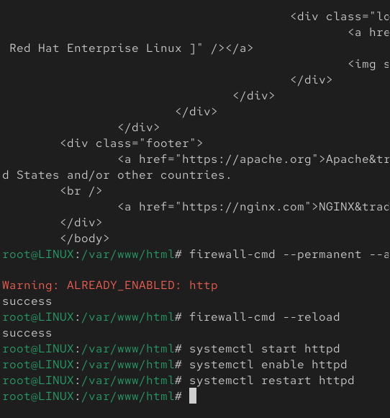
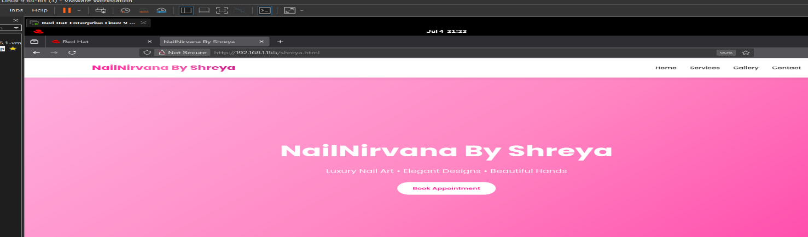

6. Hardening: Configure the system firewall to permit traffic only on ports 22 and 80.
Answer:
Configure Firewalld:
Start Firewall= #systemctl start firewalld
Enable Firewall= #systemctl enable firewalld
Allow SSH= #firewall-cmd --permanent --add-service=ssh
Allow HTTP= #firewall-cmd --permanent --add-service=http
Reload Firewall= #firewall-cmd –reload
Verify= #firewall-cmd --list-all
Expected output: services: ssh http
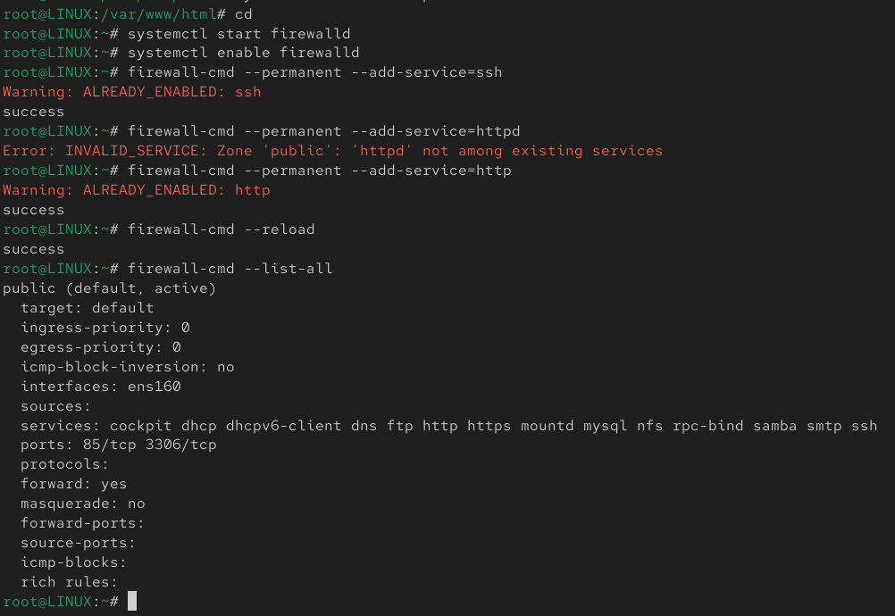

7. Automation: Script a cronjob that executes at 02:00 daily to compress /var/www into a .tar.gz archive.
Answer:
Create Backup Script= #mkdir -p /backup
Create Script= #nano /usr/local/bin/webbackup.sh
entry: #!/bin/bash , DATE=$(date +%F), tar -czf /backup/www-backup-$DATE.tar.gz /var/www
Give Execute Permission= #chmod +x /usr/local/bin/webbackup.sh
Edit Cron= #crontab -e , entry: 0 2 * * * /usr/local/bin/webbackup.sh
Verify= #crontab -l
Check Backup= #ls /backup
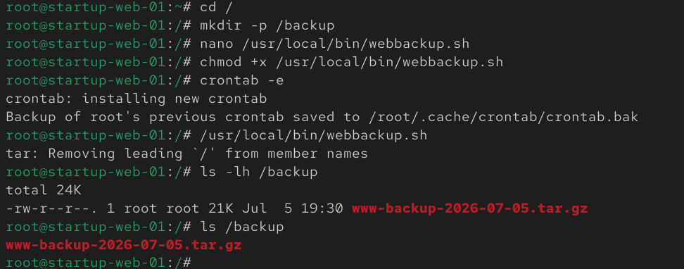
Section C: Integrated Case Study
1. Diagnosis: Which specific log files and system commands would you use to identify why the Apache service failed to start?
Answer:
#systemctl status httpd # Service running status chechk
#journalctl -u httpd = Apache service logs show
#cat /var/log/httpd/error_log = Apache error log check
#httpd -t = Configuration syntax verify
#journalctl -xe= Detailed system logs check
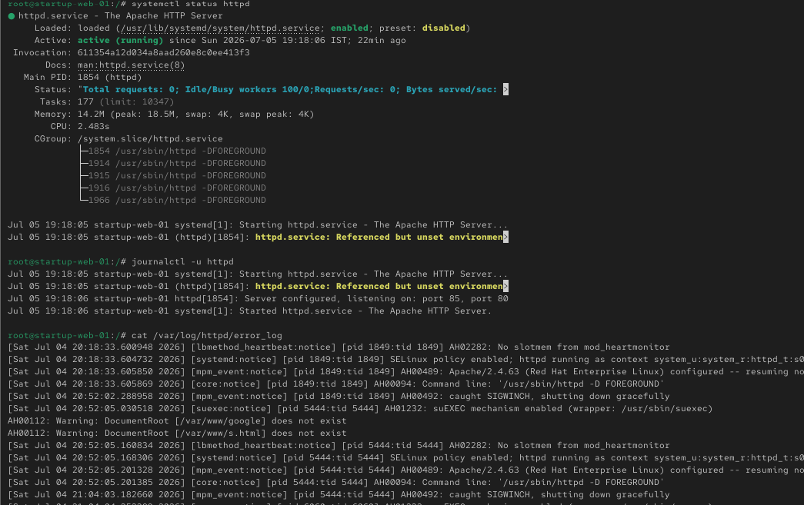
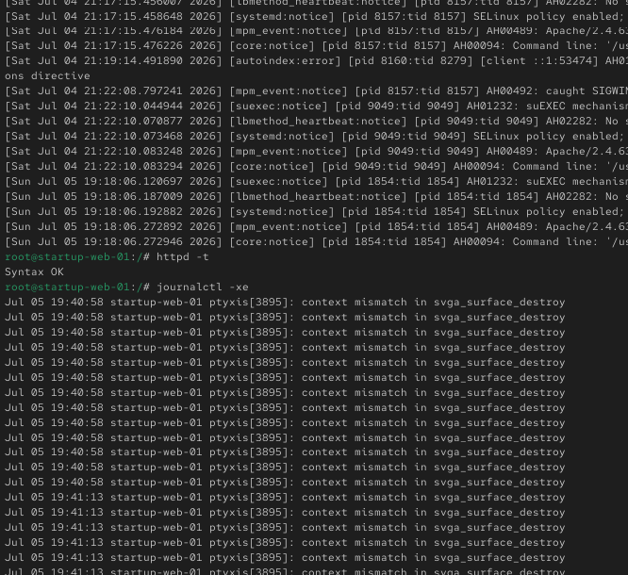

2. Connectivity: Analyze why the SSH login is experiencing high latency and suggest a fix related to DNS or authentication settings.
Answer: Reasons:
- Reverse DNS lookup
- GSSAPI authentication delay
- DNS server unavailable
Open SSH configuration= #nano /etc/ssh/sshd_config , entry: #UseDNS no
#GSSAPIAuthentication no – remove the #comnad line
Restart SSH= #systemctl restart sshd
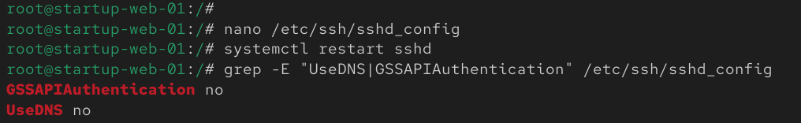

3. Recovery: Outline the step-by-step CLI process to manually restart the failed services and verify their operational status.
Answer:
Restart Apache= #systemctl restart httpd
Apache status check= #systemctl status httpd
Restart SSH= #systemctl restart sshd
SSH status check= #systemctl status sshd
Check listening ports= #ss -tulnp , Expected: LISTEN ... :22 (sshd) , LISTEN ... :80 (httpd)
Test website locally= #curl http://localhost
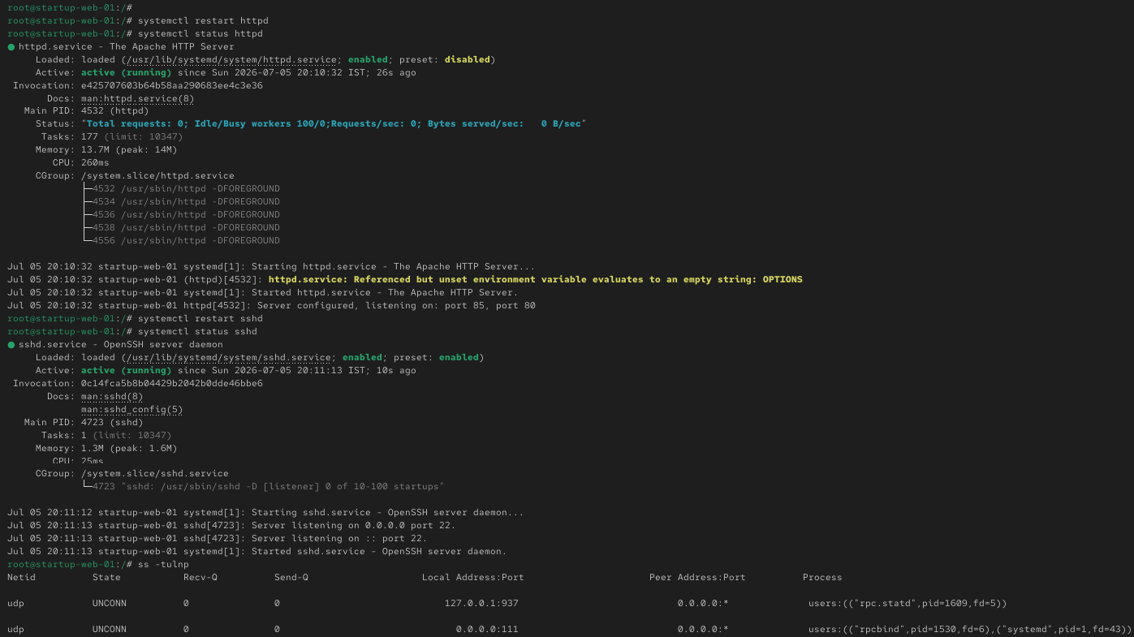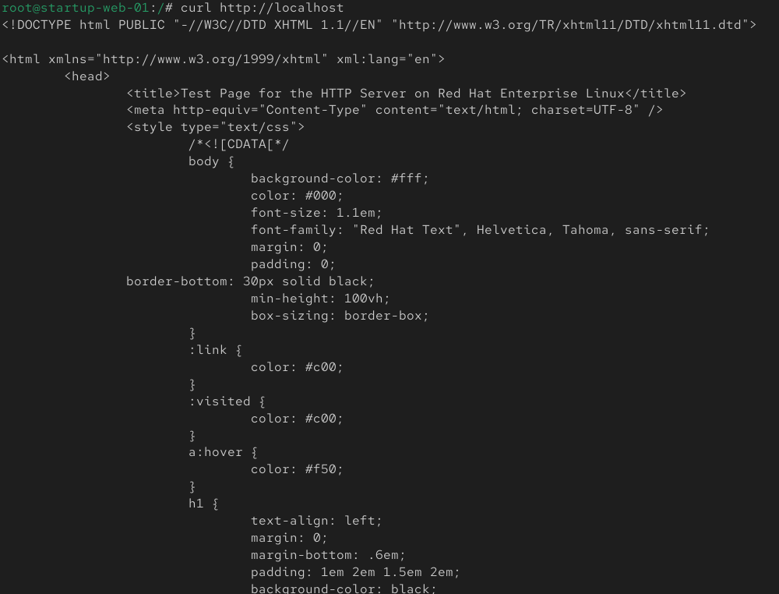

4. Preventive Action: Propose a configuration change to ensure the web server automatically attempts to restart if it encounters a runtime failure.
Answer:
#mkdir -p /etc/systemd/system/httpd.service.d = Creates the override directory.
#nano /etc/systemd/system/httpd.service.d/override.conf = Opens the override configuration file. ,
entry: [Service]
Restart=always: Automatically restarts the service if it fails.
RestartSec=5: Waits 5 seconds before restarting.
#systemctl daemon-reload= Reloads the systemd configuration.
#systemctl restart httpd= Restarts the Apache service.
#systemctl cat httpd= Displays the Apache service configuration.

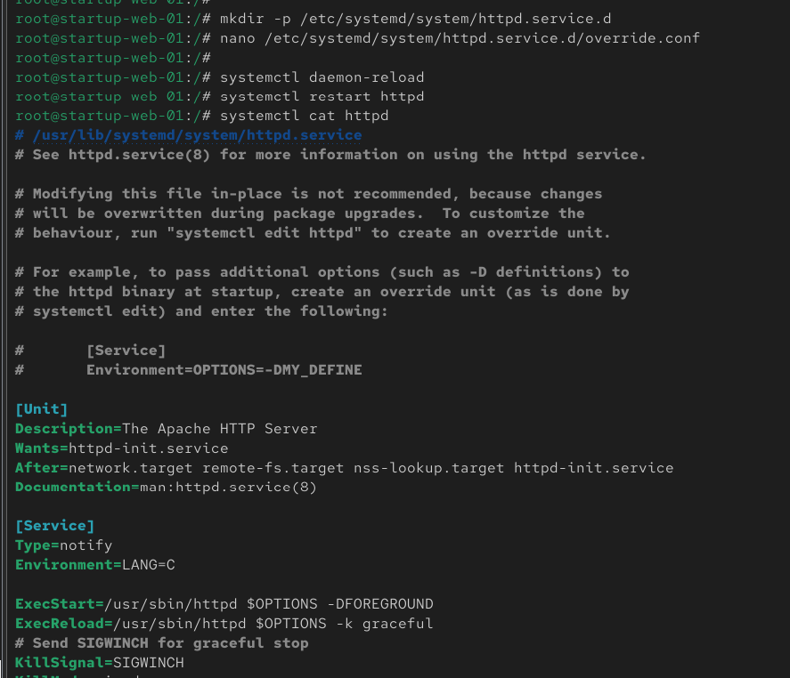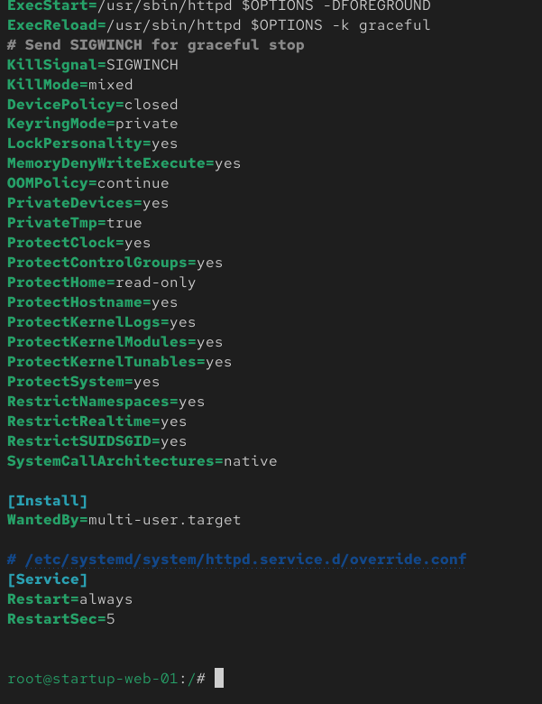
5. security: Justify the use of SSH Key-based authentication over passwords to prevent brute-force attacks during this vulnerable state.
Answer: SSH Key-based Authentication is more secure than password authentication because:
- It uses public and private key authentication instead of passwords.
- It protects the server from brute-force password attacks.
- Private keys are very difficult to guess or crack.
- It allows password login to be disabled, improving server security.
- It provides secure access for administrators, especially during server recovery or vulnerable situations.
Step 1: Generate SSH Key Pair (Client Machine)= #ssh-keygen -t rsa -b 4096
Step 2: Copy Public Key to the Server= #ssh-copy-id username@server_ip
Step 3: Login Using SSH Key= #ssh dev-ops@192.168.1.100
Step 4: Disable Password Authentication (Server)= #nano /etc/ssh/sshd_config ,
entry: PasswordAuthentication no
PubkeyAuthentication yes
restart SSH= #systemctl restart sshd
Step 5: Verify= #ssh dev-ops@192.168.1.100

